Fengdan Cui, Yunhao Zhou, Yuqing Liu, Wenbo Wu & Li Zheng

zyunha@deakin.edu.au

Information

Revision: V2.0  
Prepared for: SIT321 Assignment 2  
Prepared by: SIT321 - GROUP 6

Teaching Allocation System

System Analysis and Design

Table of Contents

1 Data Dictionary 3

1.1 User Class and Subclass 3

1.1.1 User 3

1.1.2 UserStaff 3

1.1.2 UnitChair 3

1.1.4 UserTeaAd 4

1.1.5 UserHead 5

1.2 Unit Class 5

1.2.1 Unit 5

1.3 Preference 6

1.4 Account 6

1.6 Report 7

1.7 Application and Widget 8

1.7.1 Application 8

1.7.2 Widget 8

2 Class Diagram 10

3 Sequence Diagram 11

3.1 Teaching Administrator 11

3.1.1 Verify Selection Finished 11

3.1.2 Send Email 12

3.1.3 Get Report 12

3.1.4 Decide Date 13

3.1.5 Submit All Selection Result 14

3.1.6 Add Units 15

3.1.7 Edit Unit Information 16

3.1.8 Remove Units 17

3.1.9 Suspend Accounts 18

3.1.10 Terminate Accounts 19

3.2 System Administrator 21

3.2.1 System backup and restore 21

3.2.2 Distribute accounts for academic staff 22

3.3 Academic Staff Member 24

3.3.1 Register 24

3.3.2 Login 25

3.3.3 Select Preference 26

3.3.4 Change Preference 28

3.3.5 Receive Email about Result 29

3.3.6 Modify and Adjust Allocation Result 31

4 List of References 32

# 1 Data Dictionary

## 1.1 User Class and Subclass

User means all people who will use the system and subclass includes UserStaff, UserTeaAd, UserHead and UserSysAd.

### 1.1.1 User

* Description
* A user is one who can access to the application with authorized account and current password, and he can interact with the application.
* Attribute
* Name: String

A user’s name is the unique symbol of a user which should be recorded when he logins in the system.

* Operation
* Login()

A user can interact with the system by login with account.

* Relationships
* Associations: Application (0…*:1), Account (1:1)

### 1.1.2 UserStaff

* Description
* UserStaff means academic staff members who will take advantage the application to select their preference of the units.
* Attribute
* StaffID: String

StaffID is a unique list of numbers for academic staff members to show their identification, which will be used when they register their account.

* Email: String

Email means email address of staff, which should be recorded in database and used for receiving result notice.

* Operation
* Register()

Staff should register their account with their ID number before login the application.

* SelectPre()

Staff can select preference of the units by choosing the corresponding number.

* SubmitPre()

Staff can submit the preference by clicking the button on the interface.

* ChangePre()

Staff can change their preference by choosing the corresponding number again before due date.

* Relationships
* Generations: User
* Associations: Preference (1:59), AllocatedRe (1:1)

### 1.1.2 UnitChair

* Description
* UnitChair means the unit chair of a unit, which will be selected form staff according their preference and algorithm of the system.
* Relationships
* Generations: UserStaff

1.1.3 UnitLec

* Description
* UnitLec means the unit lectures of a unit, which will be selected form staff according their preference and algorithm of the system.
* Relationships
* Generations: UserStaff

### 1.1.4 UserTeaAd

* Description
* UserTeaAd means teaching administrator, who is responsible for control the process of unit allocation.
* Operation
* ModifyRe()

Teaching administrator can modify allocated result according to the response of staff

* VerifyRe()

Teaching administrator should verify allocated result to ensure every staff is satisfied with his result and all units have been allocated currently.

* SendEma()

Teaching administrator has responsible for sending emails to staff to inform them to select preference or check allocated result in time.

* GetReport()

Teaching administrator can get the report which record all allocation statistics.

* DecideDtae()

Teaching administrator can decide the start date and end date of the activity.

* AddUnit()

Teaching administrator can add units into unit list by login the background of the system.

* ReUnit()

Teaching administrator can remove units into unit list by login the background of the system.

* EditUnitInfo()

Teaching administrator can edit information of units by login the background of the system.

* SetLim()

Teaching administrator can set the limitation about the number which can be allocated to staff by login the background of the system.

* Relationships
* Associations: Report (1:1)
* Realization: EmailApp
* Generations: User

### 1.1.5 UserHead

* Description
* UserHead is the head of education institute
* Operation
* Suspend()

The head of education institute can login the background of system to suspend account by changing the status of account.

* Relationships
* Generations: User

1.1.6 UserSysAd

* Description

UserSysAd is system administrator, who should distribute accounts for others and maintain the system.

* Operation
* DisAccount()

The system administrator can distribute accounts for other users according their identification by login the background of system.

* Maintain()

The system administrator should maintain the system such as repair bugs and backup database.

* Relationships
* Generations: User

## 1.2 Unit Class

Units are those for academic staff member to select preference and there is no subclass. Preference of staff should also be contained in unit sheet.

### 1.2.1 Unit

* Description

When staff select their preference of units, they will consider the unit information to determine whether they would like to be a lecture.

* Attribute
* UnitID: String

ID number of a unit contains character and numbers to identify a unit.

* UnitTitle: String

A unit title is the name of a unit in sheet.

* Trimester: Integer

Units are divided into three groups which will be taught in different trimesters including 1, 2, and 3, therefore, staff should take this part into consideration to decide.

* CreditPoint: Integer

The credit point should be 0 or 1.

* Operation
* AllocateChair()

Staff will be assigned as unit chair of a unit according to his preference and algorithm of the system.

* AllocateLec()

There will be several staff to be assigned as unit lectures of a unit according to his preference and algorithm of the system.

* Relationships
* Associations: UnitChair (1:1), UnitLec (1:1,2,3,4)

## 1.3 Preference

* Description

Preference is numbers to indicate the aspiration of staff when they express whether they would like to be a unit lecture.

* Attribute
* Symbol: Integer

1 represents the unit that a staff member most preferred,

2 represents the unit that a staff would like to teach,

3 represents the unit that staff can but does not like to teach,

4 represents the unit that a staff is unable to teach.

* Operation
* FillCompleted()

This operation is to check whether staff has chosen preference of all units.

* GenerateReTa()

This operation is to generate report of the allocated result.

* Relationships
* Associations: UserStaff (59:1)
* Composition: Unit (1…*:1)

## 1.4 Account

* Description

Accounts will be recorded into database for further authorize when users login the system. What’s more, accounts will be distributed for users by system administrator so that they can login with their account.

* Attribute
* AccountTitle: String

The title of account is for users to fill in the textbox which will be checked from database to be authorized before login the system.

* AccountPass: String

The password of account should be used to fill in the other textbox, which should be checked whether it is correct.

* AccountSta: Integer

The status will change if the head of education institute suspend or terminate the account and there are numbers to indicate status.

1 means active

2 means suspended

3 means terminated

* Operation
* AccValid()

This operation is to check whether the account is valid by retrieving the database before login the system. If it cannot be found out in database, the system will return message box to inform users. Otherwise, the system will check whether the password is correct.

* PassValid()

This operation will be called after checking the account, which will be used for determine whether the password is correct. If it is wrong, the system should be return message box to inform users. Otherwise, users can access to the system successfully.

* Relationships
* Associations: User (1:1)

1.5 AllocatedRe

* Description

AllocatedRe means the result of allocation

* Attribute
* Symbol: Integer

1 represents the unit that a staff member most preferred,

2 represents the unit that a staff would like to teach,

3 represents the unit that staff can but does not like to teach,

4 represents the unit that a staff is unable to teach.

* Operation
* FillCompleted()

This operation is to check whether staff has chosen preference of all units.

* GenerateReTa()

This operation is to generate report of the allocated result.

* Relationships
* Associations: UserStaff (59:1)
* Composition: Unit (1…*:1)

## 1.6 Report

* Description

A report will be generated by the system automatically for teaching administrator after all staff have chosen their preference and been satisfied with their allocated result.

* Attribute
* ReportDate: Date

Report date is to indicate the date to generate the report.

* ReportTime: Time

Report time is to indicate the time to generate the report.

* Operation
* CreateReport()

This operation is used to generate report.

* Relationships
* Associations: UserTeaAd (1:1)

## 1.7 Application and Widget

Users can interact with the application and there are widgets displayed on the interface for users to use such as buttons, textboxes.

### 1.7.1 Application

* Description

A report will be generated by the system automatically for teaching administrator after all staff have chosen their preference and been satisfied with their allocated result.

* Attribute
* AppName: String

The name of this application.

* StorageRes: String

The files and other resource of this application.

* PubDate: Date

The publish date of this application.

* Version: Float

The current version of this application.

* Status: Integer

The status of this application can be set by teaching administrator and the head of education institute to control the process of unit allocation.

1 indicates able to access

2 indicates enable to access

* Relationships
* Associations: User (0…*:1)
* Aggregation: Widget (1:0…*)

### 1.7.2 Widget

* Description

There are several kinds of widgets in an application such as buttons and textboxes, which can be used by users to interact with the application.

* Attribute
* WidTxt: String

The text content of the widget.

* WidName: String

The name of the widget.

* WidWidth: Float

The width of the widget.

* WidHeight: Float

The height of the widget.

……

* Operation
* WidSelected()

The widget can be selected by users and developers.

* WidMoved()

The widget can be moved on the interface by developers when they develop the application.

* WidDeleted()

The widget can be delected on the interface by developers when they develop the application.

* WidCut()

The widget can be cut by developers when they develop the application.

* WidCopy()

The widget can be copied by developers when they develop the application.

……

* Relationships
* Associations: Application (0…*:1)

1.7 Interface – EmailApp

* Description

There are several kinds of widgets in an application such as buttons and textboxes, which can be used by users to interact with the application.

* Attribute
* EmailDate: Date

The date when the email is created.

* EmailTime: Time

The time when the email is created.

* SenderAdd: String

The email address of sender

* ReceiverAdd: String

The email address of receiver

* Operation
* Edit()

Teaching administrator can edit the content of the email.

* Send()

Teaching administrator can send the email.

* Check()

Teaching administrator can check the email, including content and status of the email.

* Delete()

Teaching administrator can delete the email.

* Relationships
* Realization: UserTeaAd

# 2 Class Diagram

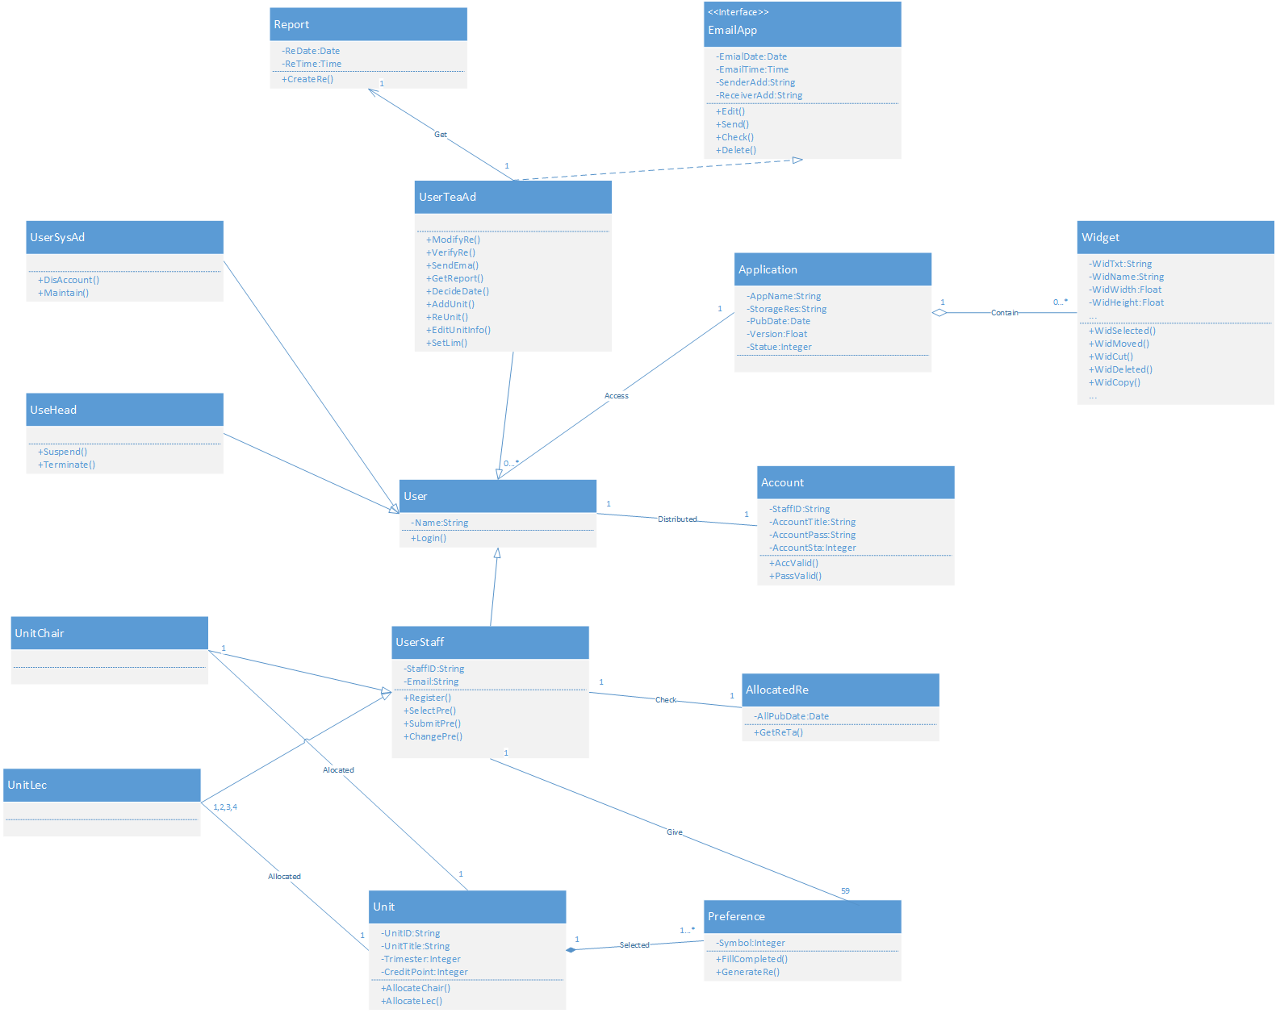

(For a clearer version of class diagram, please refer the Appendix File.)

# 3 Sequence Diagram

The sequence diagrams can be divided into four kinds according different users

## 3.1 Teaching Administrator

### 3.1.1 Verify Selection Finished

* Use Case Diagram

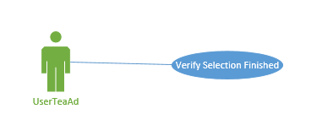

* Use Case Scenario
* Teaching administrator open the link to background of the system, filling in account name and password to login.
* Teaching administrator click the related button on the interface.
* Teaching administrator see the message box to know whether every staff has submitted their preference sheet.
* If there are someone who hasn’t submitted, teaching administrator open his email application to send message to inform.
* Sequence Diagram

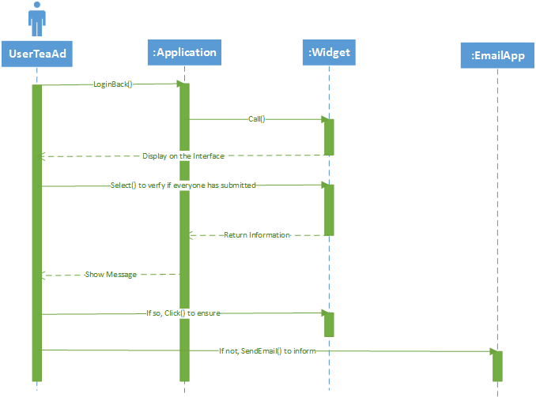

### 3.1.2 Send Email

* Use Case Diagram

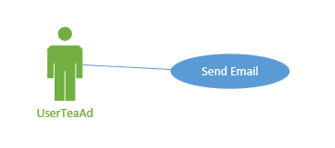

* Use Case Scenario
* Teaching administrator open email application and login with his account and password.
* Teaching administrator click “new” button to create a new email
* Teaching administrator fill in receiver’s email address and content in details
* Teaching administrator click “send” button to send the email to staff
* Sequence Diagram

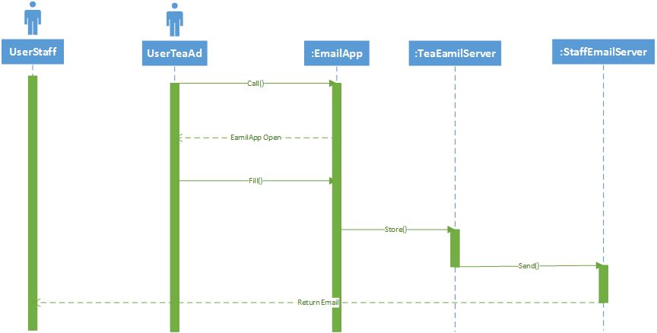

### 3.1.3 Get Report

* Use Case Diagram

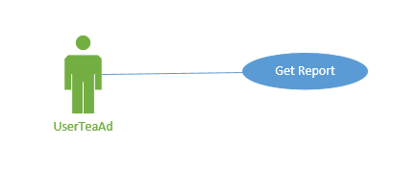

* Use Case Scenario
* Teaching administrator open the link to background of the system, filling in account name and password to login.
* Teaching administrator click the related button on the interface.
* Teaching administrator see the message box on the interface to ensure the process of generating the report.
* Teaching administrator wait for the report generated completely and download report.
* Sequence Diagram

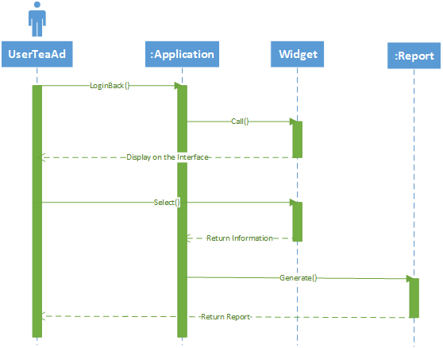

### 3.1.4 Decide Date

* Use Case Diagram

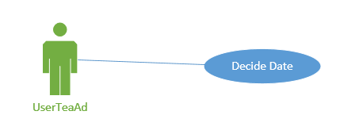

* Use Case Scenario
* Teaching administrator open the link to background of the system, filling in account name and password to login.
* Teaching administrator click the related button on the interface.
* Teaching administrator fill in the start date and end date of the unit allocation into text boxes on the interface.
* Teaching administrator click “submit” button.
* Teaching administrator can see message box to confirm the setting.
* Sequence Diagram

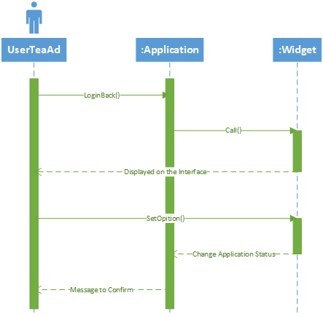

### 3.1.5 Submit All Selection Result

* Use Case Diagram

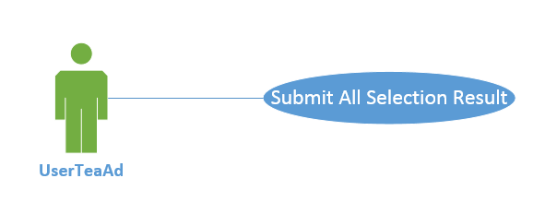

* Use Case Scenario
* Teaching administrator enter account and password into the system through the input box on user interface.
* Teaching administrator click related button into message page and to check whether every staff has submitted their preference sheet.
* Teaching administrator click the button of result submission after every staff has submitted their preference sheet.
* Sequence Diagram

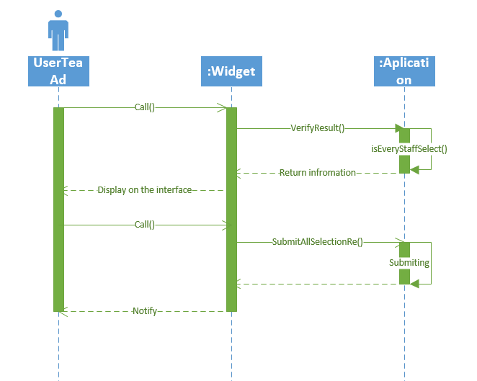

### 3.1.6 Add Units

* Use Case Diagram

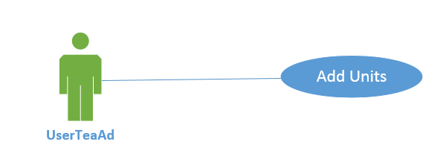

* Use Case Scenario
* Teaching administrator enter account and password into the system through the input box on user interface.
* Teaching administrator click button of adding units on the interface.
* System receives this command and check whether this adding unit has existed.
* Teaching administrator adds the information (UnitID, UnTitle, Trimester, CreditPoint) of unit on add page after system checked.
* Sequence Diagram

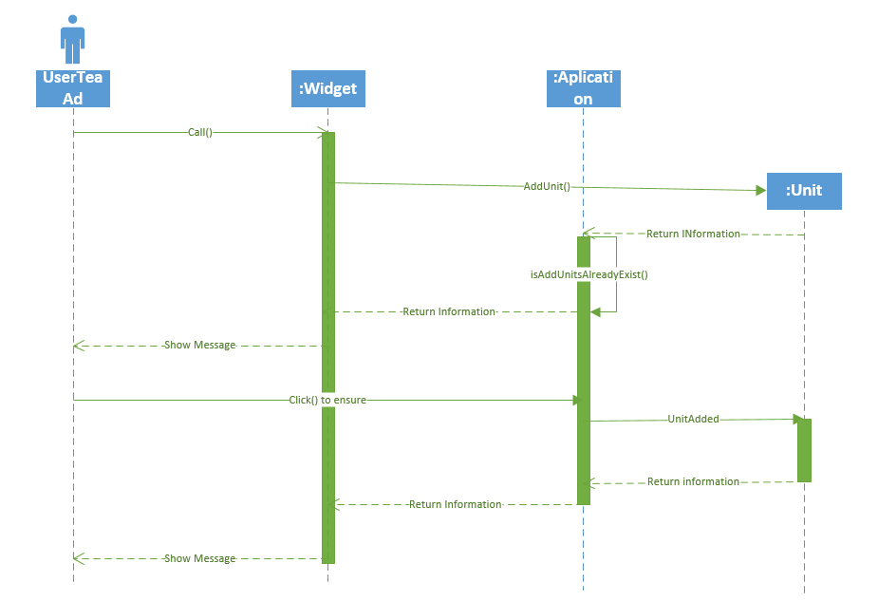

### 3.1.7 Edit Unit Information

* Use Case Diagram

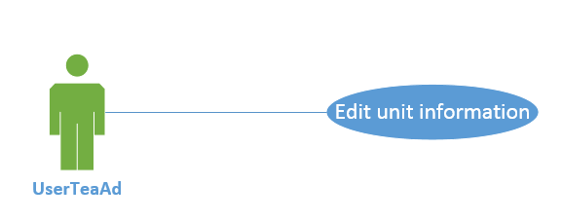

* Use Case Scenario
* Teaching administrator enter account and password into system through the input box on user interface.
* Teaching administrator click button of removing units on the interface.
* System receives this command and check if this removing unit has existed.
* Teaching administrator removes unit.
* Sequence Diagram

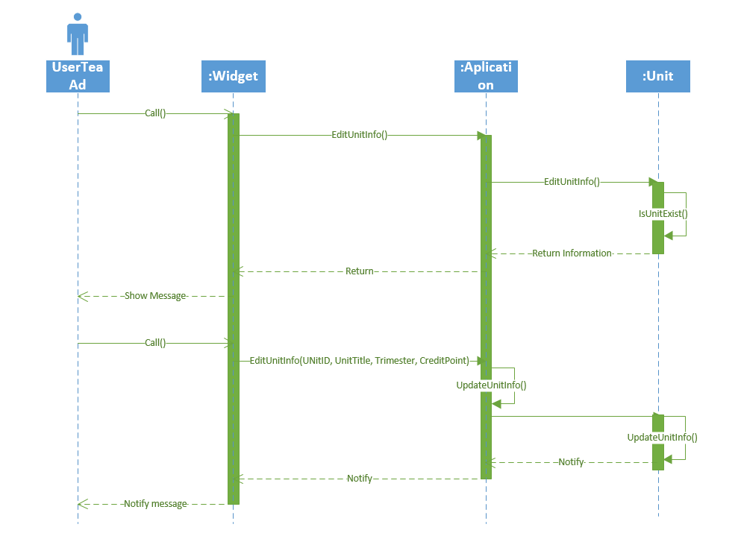

### 3.1.8 Remove Units

* Use Case Diagram

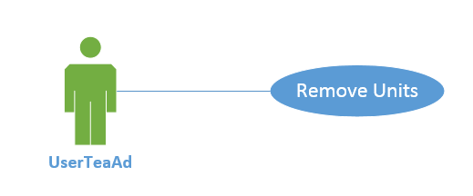

* Use Case Scenario
* Teaching administrator enter account and password into system through the input box on user interface.
* Teaching administrator click button of editing units on the interface.
* System receives this command and check if this editing unit has existed.
* Teaching administrator edit information (UnitID, UnitTitle, Trimester, CreditPoint) on editing page after system checked.
* System updates unit’s information.
* Sequence Diagram

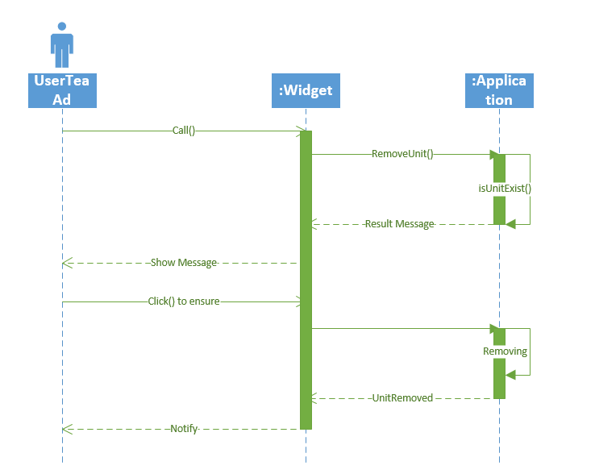

### 3.1.9 Suspend Accounts

* Use Case Diagram

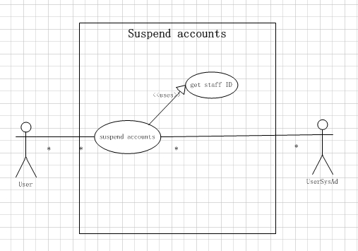

* Use Case Scenario
* Teaching Administrator open the link to background of the system, filling in account name and password to login.
* Teaching Administrator click widget.
* Teaching Administrator click related button on the interface.
* Teaching Administrator check the message box to know whether account has been suspended.
* Sequence Diagram

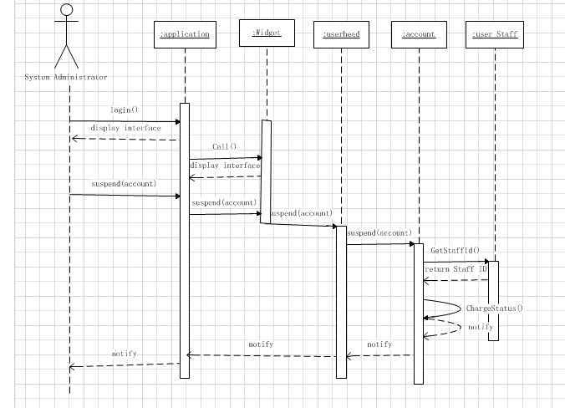

### 3.1.10 Terminate Accounts

* Use Case Diagram

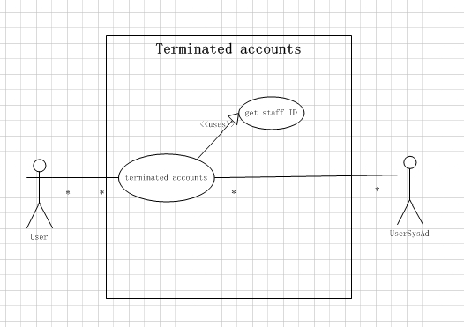

* Use Case Scenario
* Teaching Administrator open the link to background of the system, filling in account name and password to login.
* Teaching Administrator click widget.
* Teaching Administrator click related button on the interface.
* Teaching Administrator check the message box to know whether account has been terminated.
* Sequence Diagram

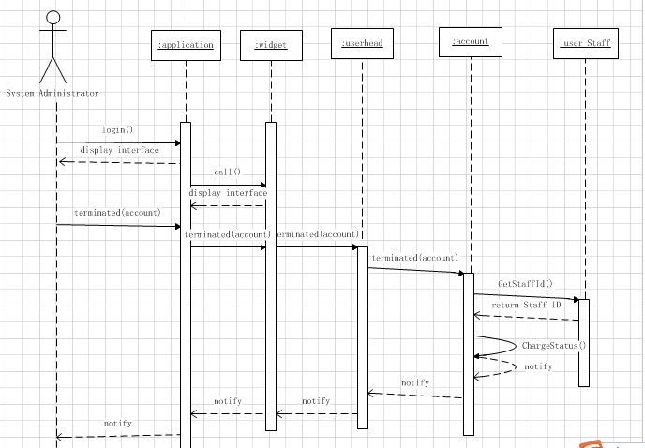

## 3.2 System Administrator

### 3.2.1 System backup and restore

* Use Case Diagram

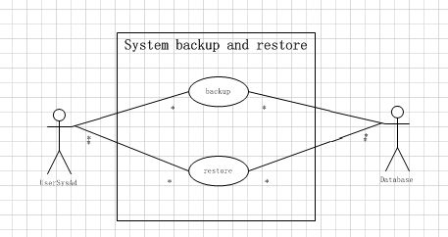

* Use Case Scenario
* System Administrator open the link to background of the system, filling in account name and password to login.
* System Administrator click widget.
* System Administrator click related button on the interface.
* System Administrator check the message box to know whether system backup and restore is success.
* Sequence Diagram

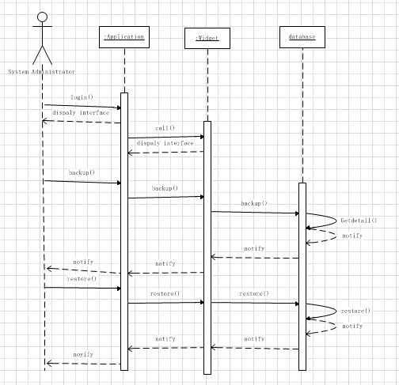

### 3.2.2 Distribute accounts for academic staff

* Use Case Diagram

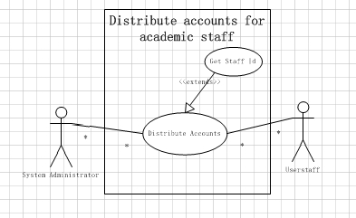

* Use Case Scenario
* System Administrator open the link to background of the system, filling in account name and password to login.
* System Administrator click widget.
* System Administrator click related button on the interface.
* System Administrator check the message box to know whether every staff has get accounts.
* Sequence Diagram

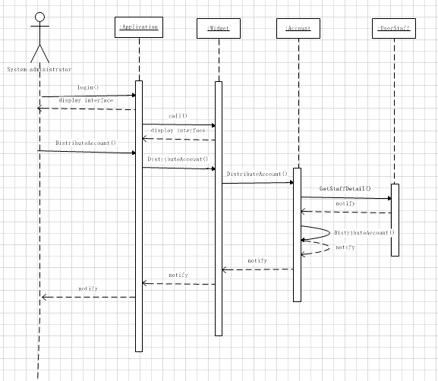

## 3.3 Academic Staff Member

### 3.3.1 Register

* Use Case Diagram

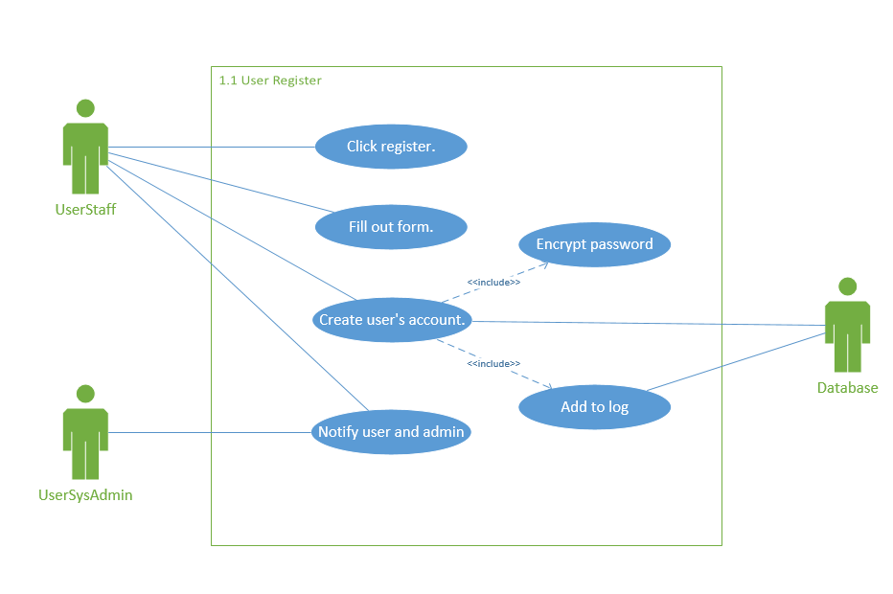

* Use Case Scenario
* The user staff click register button.
* The user staff fill out the form for detailed information.
* The user staff click create account.
* User’s password is encrypted.
* The user’s account is added to log.
* The system notifies the user and administrator that account was successfully created.
* Sequence Diagram

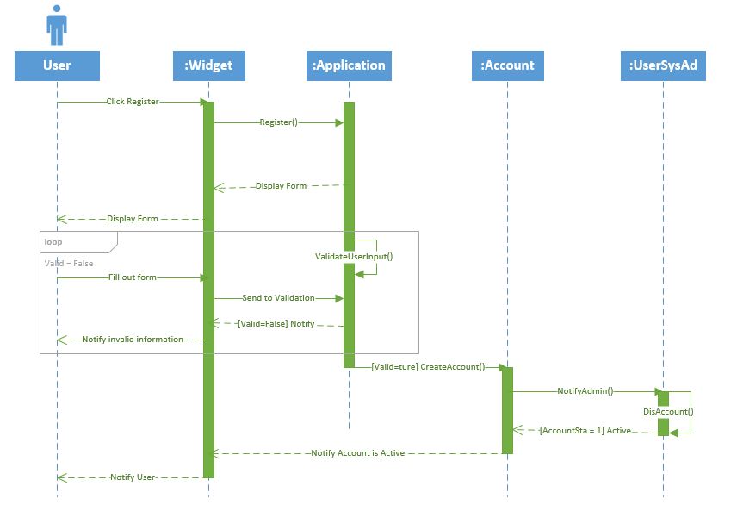

### 3.3.2 Login

* Use Case Diagram

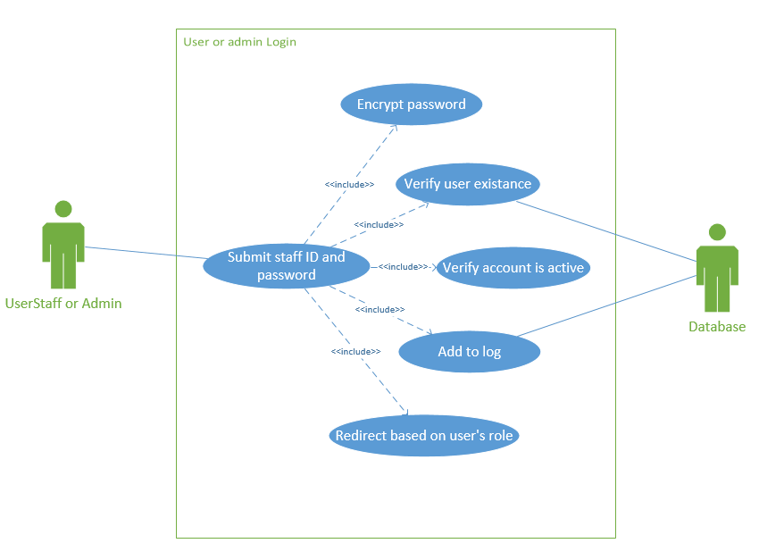

* Use Case Scenario
* The user submit staff ID and password.
* User’s password is encrypted.
* The system verifies user’s existence.
* The system verifies the status of the account.
* The system redirect the contents to the user based on user’s role.
* Sequence Diagram

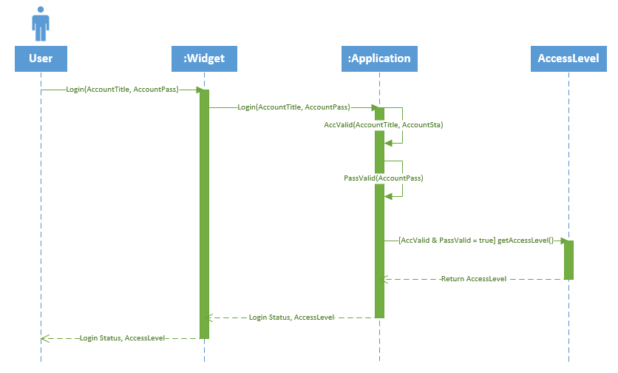

### 3.3.3 Select Preference

* Use Case Diagram

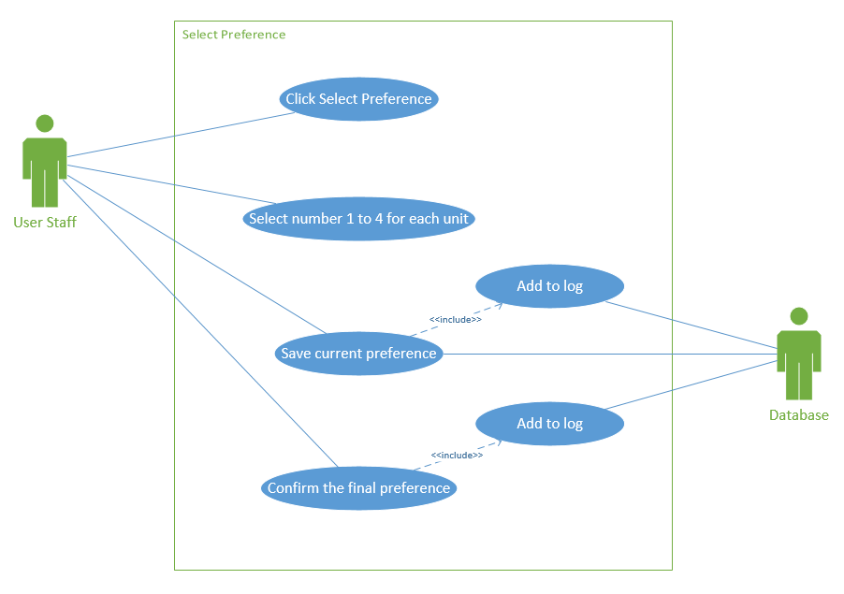

* Use Case Scenario
* The user click select preference.
* The user fill the preference form.
* The user click save the current preference.
* The preference is saved in the database.
* The user click submit the final preference.
* The final preference is confirmed and added to log.
* Sequence Diagram

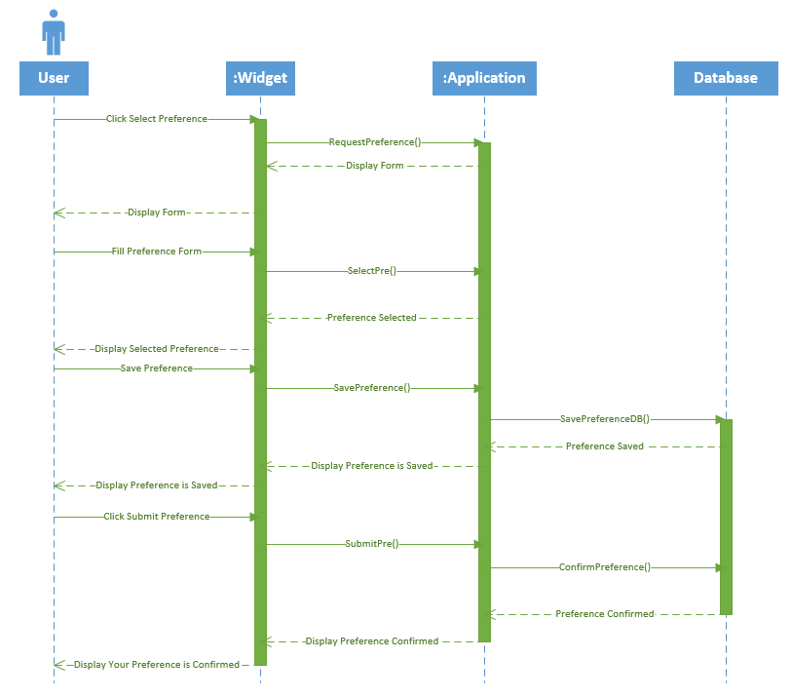

### 3.3.4 Change Preference

* Use Case Diagram

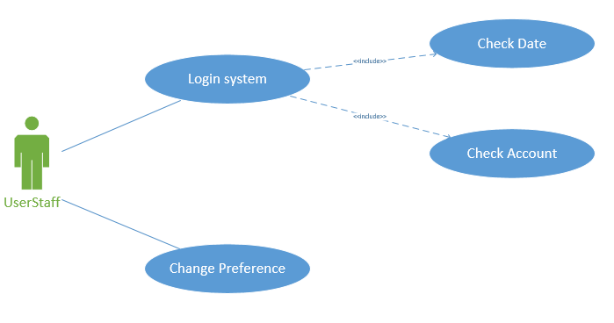

* Use Case Scenario
* Some teaching staffs want to change selected preference before due date
* They login the system and change their preference in the valid duration.
* Sequence Diagram

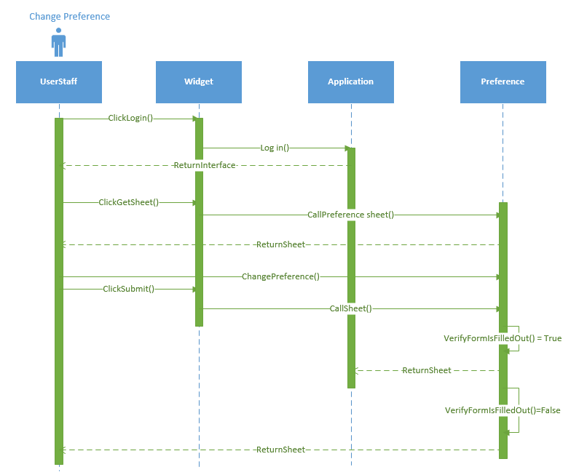

### 3.3.5 Receive Email about Result

* Use Case Diagram

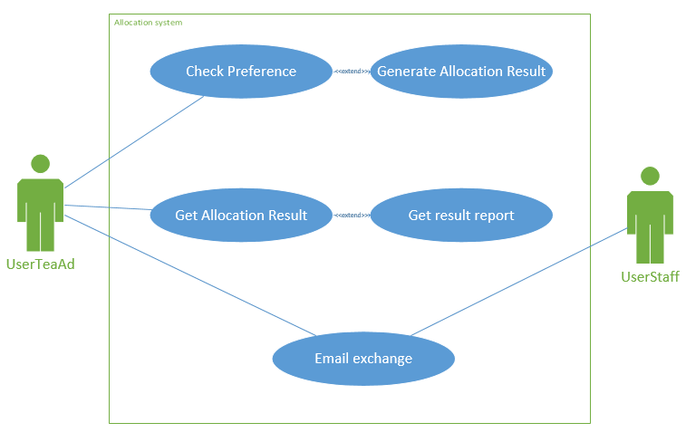

* Use Case Scenario
* After teaching administrator submit all selected preference to allocation system, this system will return an allocation result to administrator.
* Therefore, teaching administrator have responsibility to notice teaching staff that the checking allocation result is available.
* Sequence Diagram

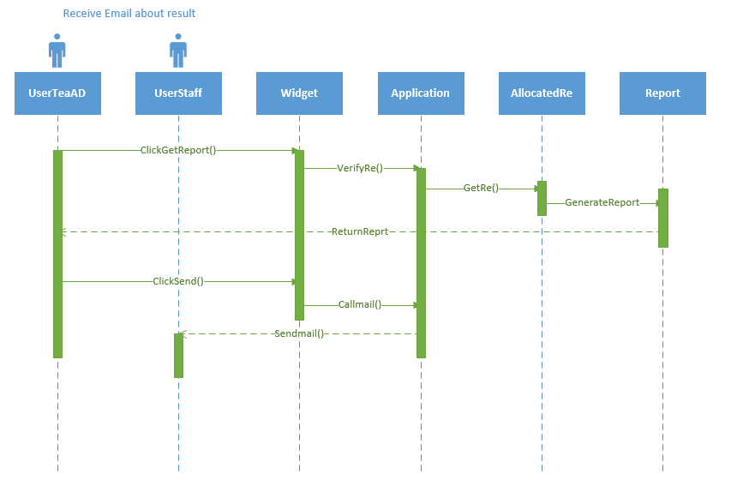

### 3.3.6 Modify and Adjust Allocation Result

* Use Case Diagram

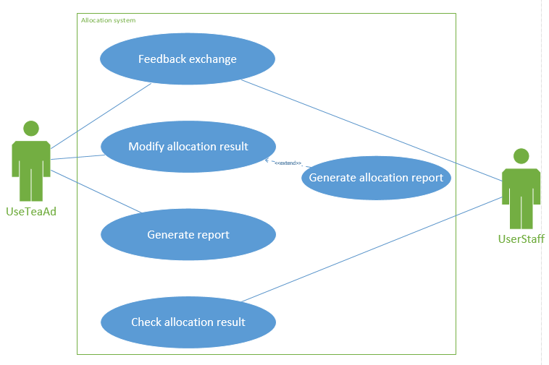

* Use Case Scenario
* Teaching administrator will receive some advice about allocation result from teaching staff they have checked result.
* Therefore, teaching administrator could modify the result in the system according to these advice and real situation.
* Sequence Diagram

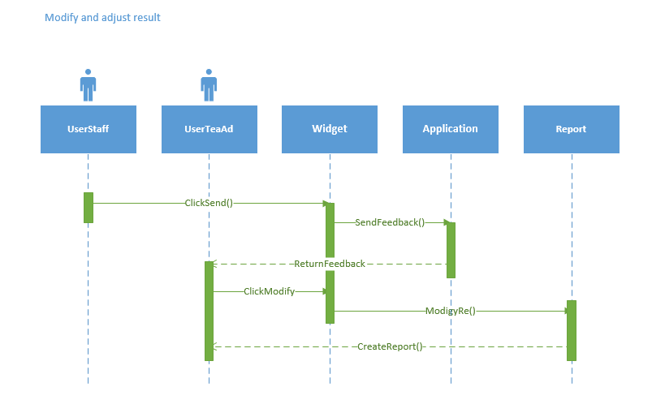

# 4 List of References

SIT321 Lecture Sources, Deakin University, Burwood

SIT321, Tutorial, Deakin University, Burwood